**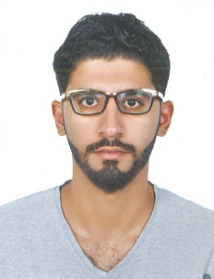*CURRICULUM VITAE***

**ABDULLA ADEL DARWISH ABDULRAHMAN ALTAMIMI**

East Riffa - Hajiyath

Kingdom Of Bahrain

Mobile: 33631973

E-mail: [abdullaaltamimi10@gmail.com](mailto:abdullaaltamimi10@gmail.com)

**Objective:**

To Work in an Environment which offers good opportunity to share my Knowledge and Skills with others and participate myself and work towards for a complete satisfaction of the company.

**PERSONAL DETAILS:**

Nationality : Bahraini

Date of Birth : 04-11-1999

Sex : Male

Marital Status : Single

CPR No. : 991101529

Languages Known : Arabic, English

Driving License Details : Valid Bahrain license

**Education & Qualifications:**

* Secondary School completed with 85% at East Riffa Boys Secondary School 2017.
* Successfully completed Basic Security Operative Course( Security Guard) From Guards Training School(24th Feb 2019)
* Security Guard 06/02/2019 G4S Secure Solutions Bahrain.
* Observed and reported the criminal activities.
* Maintained law and order on the assigned properties.
* Assisted the public in all possible manner.

**Declaration**

I hereby declare that above given details are true and correct to the best of my knowledge and belief.

**ABDULLA ADEL DARWISH ABDULRAHMAN ALTAMIMI**